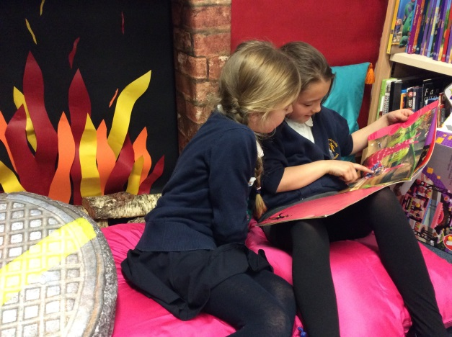
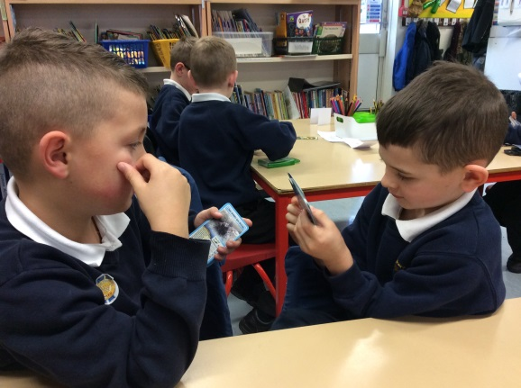
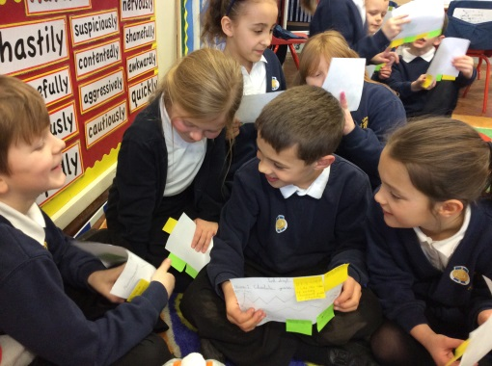
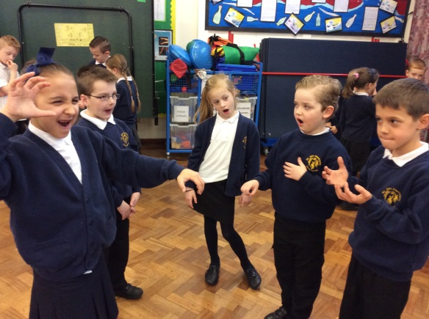
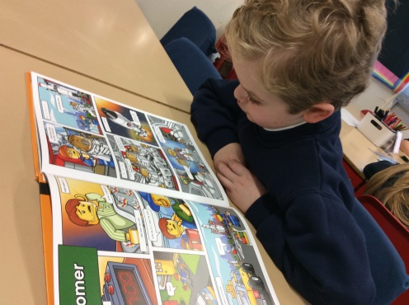
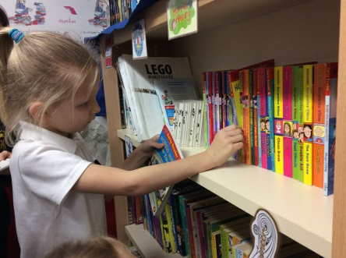
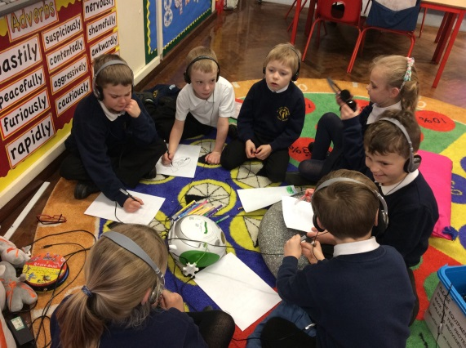
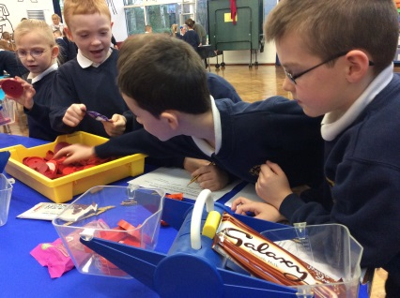
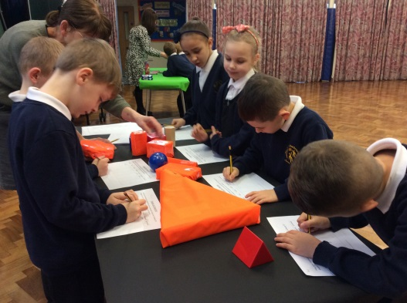
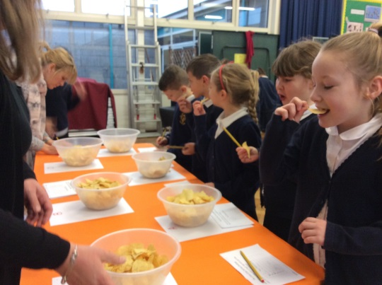
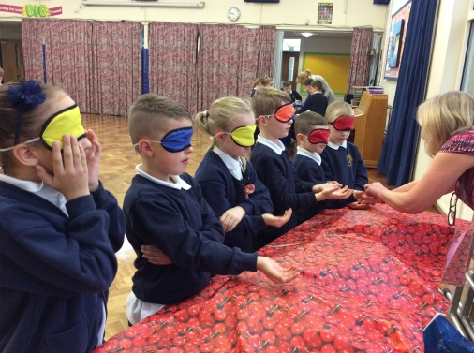
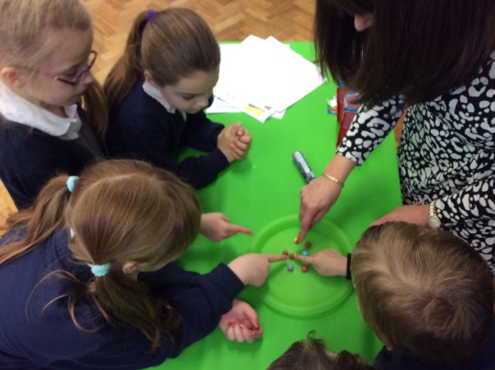
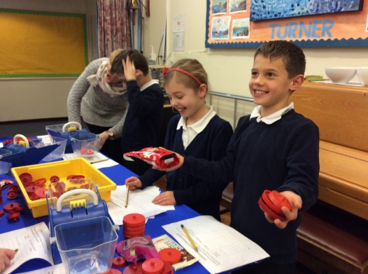

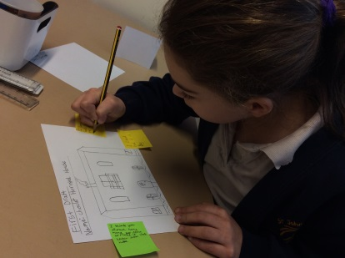
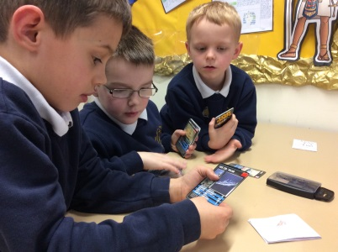









WOW Moments

Already some of our children took part in the Young Voices schools’ choir event at the Sheffield Arena on Monday Jan 9th. The children were part of a choir of over 5 000 children from different schools, a hair raising and spine tingling experience !
For more WOW moments, please see the photos on the back of this newsletter.
Please let us know if your child has achieved anything outside of school, so we can all celebrate in their WOW moments.
Curriculum Focus
Our topic this term is World War 2 and the children are very enthusiastic to learn more about this very important and amazing topic. This will provide the focus for our writing, history, geography, RE and artwork. We aim to organise a visit to the National Holocaust Centre near Newark, to learn more about this challenging and important aspect of the conflict.
There are many good websites for the children to visit. As always, a good place to start is: http://www.bbc.co.uk/schools/primaryhistory/world_war2/
English
We will focus on a novel by Michael Morpurgo, Friend or Foe that deal with evacuees from London and use this to write diaries and letters. We will also look at biographical writing to learn about some of the leaders involved in WW2. Our regular comprehension and grammar work will also continue.
Maths
In maths we will spend the first part of the term looking at multiplication and division, including mental and written methods and their application through word problems.
Science
This term’s science will focus on forces, and light. However, we will also be taking part in some of the BBC’s exciting new science resources and contributing to nationwide experiments.

Topic
Every term your child’s topic will involve Art/DT, RE, PSHE, Geography/History.

PE Lessons take place on the following days: Monday and Tuesday.
Please make sure your child brings their kit into school on a Monday and leaves it in the classroom until the Friday. For the first part of the term PE will be hockey, (working towards organising a team for an interschools tournament ) and Zumba. Both these will be led by specialist external providers. Y5 can take part in lunchtime football withMr Tilling on alternative Tuesdays starting January 17th.

Year 5 Spring Newsletter 2017
We would like to take this opportunity to wish all parents and carers a Happy New Year. Christmas seems a distant memory, now that we have been back in school for 8 days. We are excited about the term ahead, with many things to look forward to. As we look at WW2 this term, we would love to hear from anybody who has personal memories from that time, who may be willing to be interviewed and filmed ! The film would then be shown in a class assembly.

A LITTLE NOTE
As w start on this new term, we are hoping that some parents or grandparents could spare some time to help with reading and other activities such as cooking, sewing and art. If you are able to help please would you let Mr Outram and Mr Knott know. We really appreciate any help whether this is weekly or just as a one off. Thank you to all those helpers from last term.
Please make sure your child brings their reading folder, with books and reading diary, to school everyday. They may read on extra days as well as in their guided reading group. It is important that the children continue to work on their target of reading at home to an adult 3 times a week, more if possible. Their reading diaries will be checked every Friday and merits will be awarded to those children who have read at least 3 times that week.
HOMEWORK
Weekly
- Read with an adult at least 3 times a week.
- Practice their timestables – in and out of order and division facts.
- Learn their spellings – these will be given out on a Thursday and tested the following Thursday.
Other
Extra maths homework will be given out throughout the term when the teacher feels it is needed.

One off creative Topic homework may be set to be done over a holiday break, depending on the topic.
Dates to Remember
Jan 23rd - E Safety Meeting for parents at 5:00pm
Feb 10th – INSET day and break up for half term.
Feb 20th – Return to school.
Feb 24th – Year 5 Bikeability (rearranged from last term)
Week beginning Feb 27th – Parents’ Evenings
Mar 1st – Y5 Hockey tournament at CFS (am)
Mar 13th – SRE session will take place this week
w/b March – 22nd Cross Country Meeting (am)
Mar 24th – Filthy Friday at Manor Park (more details to follow)
YORK VISIT MEETING … to be arranged
Visit to National Holocaust Centre … to be arranged

