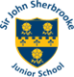
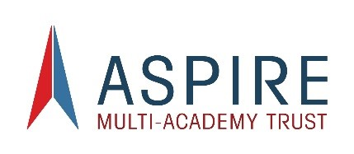

Admissions Consultation

18th December 2024 to 31st January 2025

Sir John Sherbrooke Junior School
Flatts Lane
Calverton
Nottingham
Nottinghamshire
NG14 6JZ
Phone: (0115) 965 2291
Fax: (0115) 965 5701
Email: office@sirjohnsherbrooke.notts.sch.uk
Headteacher: Mrs Rebecca Mee

Sir John Sherbrooke Junior School is a junior school located in Calverton, Nottinghamshire. The Aspire Multi-Academy Trust is the admissions authority for the school.

The School Admissions Code 2021 requires that all admission authorities undertake a statutory consultation to seek the views and comments of anyone who may be affected.

All schools must have admission arrangements that clearly set out how children will be
admitted, including information about what happens if there are more applications than places available (oversubscription criteria). The criteria must be reasonable, clear, objective,
procedurally fair and comply with all relevant legislation, including equalities legislation. It is for the admissions authority to decide which criteria are most suitable for the school, according to local circumstances.

From 18th December 2024 to 31st January 2025 the school is consulting on its admission arrangements.

Reason for Consultation:
The School Admissions Code 2021 requires admission authorities to consult on their admission arrangements at least once every 7 years, even if there have been no changes during that
period.

The school is going out to consultation in order to be compliant with this requirement in the Admissions Code 2021. The school’s admission arrangements are unchanged from 2025-26.

Consultation Information:

Full details of the admissions consultation can be found on the school’s website:
https://www.sirjohnsherbrooke.co.uk/admissions/
A hard copy of the consultation information is also available upon request from the school office.

Who are we consulting with?

The School Admissions Code 2021 requires that all admission authorities undertake a statutory consultation to seek the views and comments of parents/carers, other admission authorities, pre-schools, nurseries in the relevant area, Nottinghamshire County Council, neighbouring
local authorities and anyone else who may be affected by the consultation.

The consultation will run for a period of 6 weeks commencing on 18th December 2024 and closing on 31st January 2025 at 5pm. A copy of the School Admissions Code 2021 can be found at School admissions code - GOV.UK

How can you respond to the consultation?

We welcome and invite you to send your comments regarding the proposed arrangements in one of the following ways -

Submit an online response form using the link or QR code below: https://forms.office.com/e/3BbPt5054A
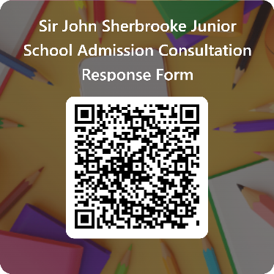
Complete a hard copy response form, available from the school office.

Send an email to the Chair of Governors at office11@sirjohnsherbrooke.notts.sch.uk
Write to the Chair of Governors at the school address shown above.

What happens next?

After the consultation period has closed the local governing body will give consideration to the responses received. They will then determine the final admission arrangements for 2026-27. Following determination, the arrangements will be published on the school’s website.

Mrs R Mee Mr M Hope
Head Teacher Chair of Governors

